www.dogwalkers.com

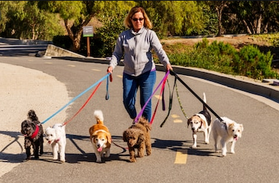

NEED A DOG WALKER?

- Affordable, friendly and professional dog walking services.
- We walk dogs, giving them socialization and exercise they need to be healthy.
- Our staff are insured and experienced.
- Our services are offered at competitive rates.

DOG WALKING*
- 30 minutes’ dog walks
- 45 minutes’ dog walks
- 60 minutes’ dog walks
* discounts offered for multiple dogs.

For bookings and additional information, contact us at: 303-dogwalkers

